Patient Survey results June 2021

An electronic survey was sent out to all patients with a mobile number registered at Partington Family Practice – a total of 4,887 patients.

The survey was also posted on our Facebook page.

A total of 437 responses were received.

The results are as follows:
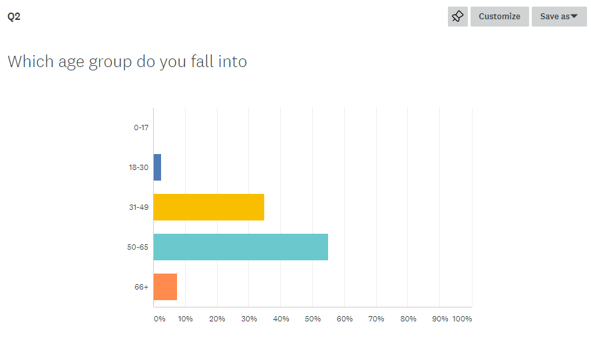
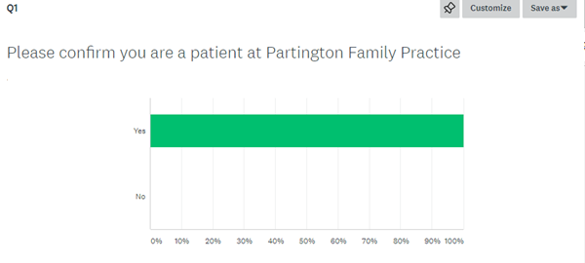
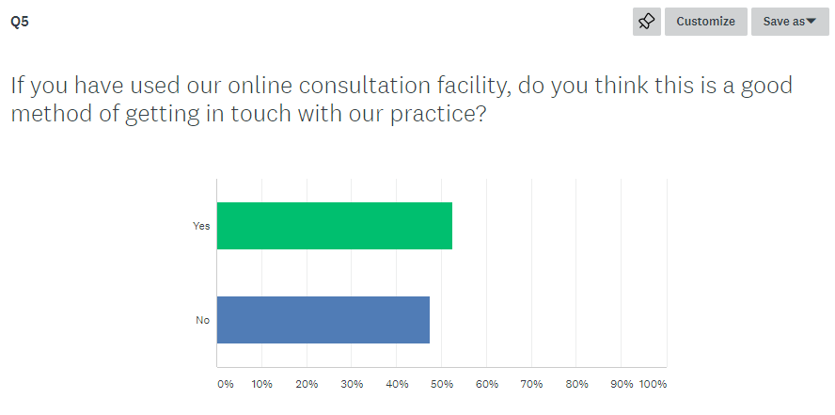
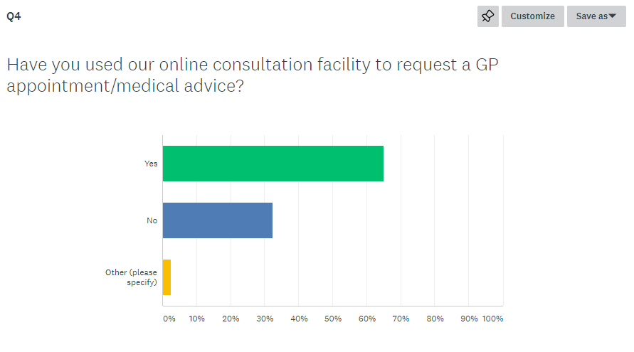
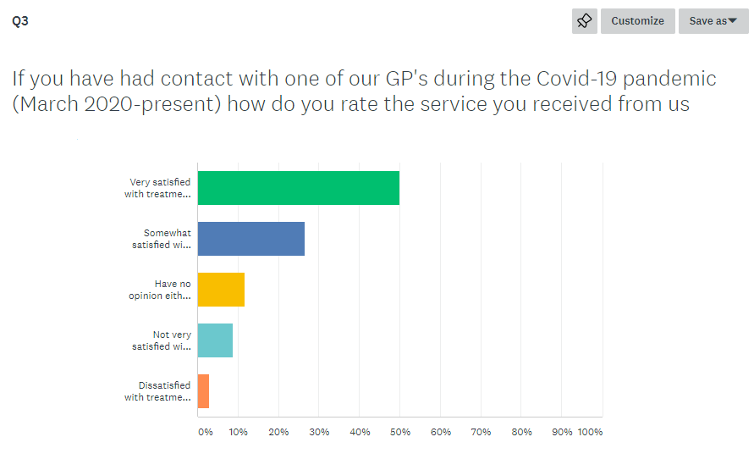

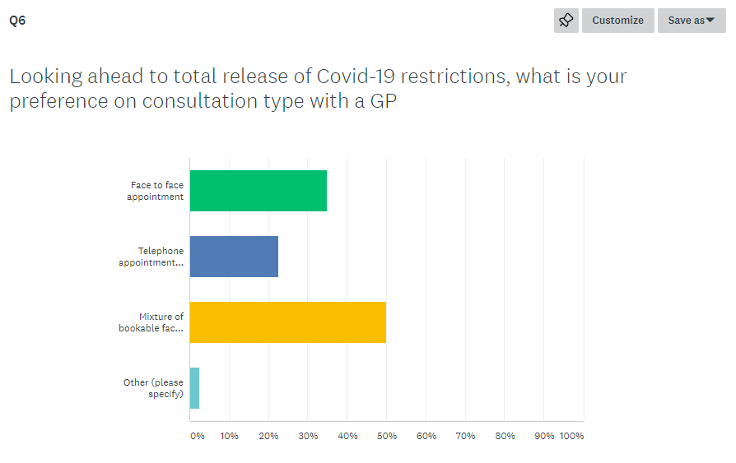

A selection of the written responses which reflect the general consensus include:

